The data set consists of tabulated MTTR (mean time to resolve) tickets on a daily basis where weekends have been omitted. Only the MTTR column is used for calculating/testing ranks. Test of rank is used because it is more robust for time-series data. The chosen level of significance for both tests is 0.05.
 |  |  | n = 10 |  |  | n > 10
Date | Tickets | MTTR | Rank | $$\sum_{i=1}^{n-1}{{\left[rank\left(X_{i}\right)-\left(X_{i+1}\right)\right]}^{2}}$$ | $$\sum_{i=1}^{n}{{\left[rank\left(X_{i}\right)-\frac{\left(n+1\right)}{2}\right]}^{2}}$$ | Rank | $$\sum_{i=1}^{n-1}{{\left[rank\left(X_{i}\right)-\left(X_{i+1}\right)\right]}^{2}}$$ | $$\sum_{i=1}^{n}{{\left[rank\left(X_{i}\right)-\frac{\left(n+1\right)}{2}\right]}^{2}}$$
Mar 2 | 3218 | 9.4 | 3 | 4 | 6.25 | 3 | 4 | 72.25
Mar 3 | 2966 | 8.7 | 1 | 16 | 20.25 | 1 | 16 | 110.25
Mar 4 | 2759 | 10.2 | 5 | 12.25 | 0.25 | 5 | 20.25 | 42.25
Mar 5 | 2611 | 12.6 | 8.5 | 0 | 9 | 9.5 | 0 | 4
Mar 6 | 2355 | 12.6 | 8.5 | 20.25 | 9 | 9.5 | 30.25 | 4
Mar 9 | 2976 | 9.7 | 4 | 4 | 2.25 | 4 | 4 | 56.25
Mar 10 | 2727 | 9.2 | 2 | 16 | 12.25 | 2 | 16 | 90.25
Mar 11 | 2759 | 11.2 | 6 | 1 | 0.25 | 6 | 4 | 30.25
Mar 12 | 2811 | 11.8 | 7 | 9 | 2.25 | 8 | 9 | 12.25
Mar 13 | 2144 | 13.3 | 10 | - | 20.25 | 11 | 16 | 0.25
Mar 16 | 2937 | 11.3 |  |  |  | 7 | 25 | 20.25
Mar 17 | 2853 | 13.9 |  |  |  | 12 | 4 | 0.25
Mar 18 | 2656 | 15.2 |  |  |  | 14 | 1 | 6.25
Mar 19 | 2743 | 17 |  |  |  | 15 | 1 | 12.25
Mar 20 | 2285 | 20.2 |  |  |  | 16 | 9 | 20.25
Mar 23 | 3128 | 14.8 |  |  |  | 13 | 16 | 2.25
Mar 24 | 2752 | 21.5 |  |  |  | 17 | 1 | 30.25
Mar 25 | 2638 | 22.8 |  |  |  | 18 | 1 | 42.25
Mar 26 | 2294 | 23.4 |  |  |  | 19 | 1 | 56.25
Mar 27 | 1912 | 24.6 |  |  |  | 20 | 1 | 72.25
Mar 30 | 2925 | 28.8 |  |  |  | 21 | 1 | 90.25
Mar 31 | 2726 | 39.4 |  |  |  | 22 | - | 110.25

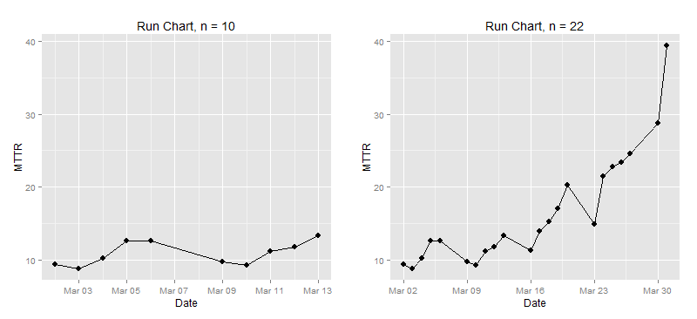
Exact Test for Small Sample, n=10  $$NM=\sum_{i=1}^{n-1}{{\left[rank\left(X_{i}\right)-\left(X_{i+1}\right)\right]}^{2}} \\ NM=82.5 \\ RVN= \frac{\sum_{i=1}^{n-1}{{\left[rank\left(X_{i}\right)-\left(X_{i+1}\right)\right]}^{2}}}{\sum_{i=1}^{n}{{\left[rank\left(X_{i}\right)-\frac{\left(n+1\right)}{2}\right]}^{2}}} \\ RVN= \frac{82.5}{82} \\ RVN=1.006$$H_{O}: The sequence of MTTR is random  H_{A}: The sequence of MTTR follows a trend  $$NM = 82.5 ≤ {NM}_{α(0.05)}=85$$  $$P\left[NM≤82.5 \right|{ H}_{O} is true]> 0.0260$$  Based on exact test on both critical and p-value methods, the null hypothesis is rejected; there is significant trend.  _______________________________________  Beta Approximation for RVN, n=22  From computation above of $RVN=1.006$H_{O}: The sequence of MTTR is random  H_{A}: The sequence of MTTR follows a trend  $${RVN}_{obs} = 1.006 ≤ {RVN}_{α(0.05)}=1.32$$  $$P\left[RVN≤1.006 \right|{ H}_{O} is true]>0.005$$  Based on beta approximation test on both critical and p-value methods, the null hypothesis is rejected; there is significant trend. | Normal Approximation w/o Continuity Correction, n=22  $$NM=\sum_{i=1}^{n-1}{{\left[rank\left(X_{i}\right)-\left(X_{i+1}\right)\right]}^{2}} \\ NM=180.5 \\ RVN= \frac{\sum_{i=1}^{n-1}{{\left[rank\left(X_{i}\right)-\left(X_{i+1}\right)\right]}^{2}}}{\sum_{i=1}^{n}{{\left[rank\left(X_{i}\right)-\frac{\left(n+1\right)}{2}\right]}^{2}}} \\ RVN= \frac{180.5}{885} \\ RVN=0.2040 \\ E\left[RVN\right]=2 \\ Var= \frac{4\left(n-2\right)\left(5n^{2}-2n-9\right)}{{5n\left(n+1\right)\left(n-1\right)}^{2}} \\ Var=\frac{4\left(22-2\right)[5\left({22}^{2})-2(22)-9\right)]}{{5\left(22\right)\left(22+1\right)\left(22-1\right)}^{2}} \\ Var=0.1698 \\ RVN \sim N\left(μ=2, σ^{2}=0.1698\right) \\ Z=\frac{0.2040-2}{\sqrt{0.1698}}= -4.360$$  H_{O}: The sequence of MTTR is random  H_{A}: The sequence of MTTR follows a trend  $$Z = -4.360 ≤ Z_{α}=-1.645$$  $$P\left[Z≤-4.360 \right|{ H}_{O} is true]<0.0002$$  Based on normal approximation using asymptotic distribution without continuity correction, null hypothesis is rejected; there is significant trend. This also supports the exact test using RVN statistic.

# Code block to install packages
is.installed <- function(x) {
is.element(x, installed.packages()[,1])
}
# Uses randtests package instead of lawstat
ifelse(!is.installed('randtests'), install.packages('randtests'), require(randtests))
# Since the dataset is too long to be in a vector, I prepared a CSV file in a dataframe format instead
url <- 'https://raw.githubusercontent.com/foxyreign/MasterOfStatistics/master/Stat%20266/Stat%20266%20-%20Assignment%201%20(Runs%20and%20Ups%20and%20Downs).csv'
download.file(url, "MTTR.csv")
assign1 <- read.csv('MTTR.csv', head = T, sep = ',')
head(assign1)
## Date Tickets MTTR
## 1 2015-03-02 3218 9.4
## 2 2015-03-03 2966 8.7
## 3 2015-03-04 2759 10.2
## 4 2015-03-05 2611 12.6
## 5 2015-03-06 2355 12.6
## 6 2015-03-09 2976 9.7
assign1$Date <- as.Date(assign1$Date, format = '%Y-%m-%d') # Converts to datetime series format
assign1$Subset <- ifelse(assign1$Date < '2015-03-13', 'Exact Test', 'Normal Approx')
mttr.range <- range(assign1$MTTR)
# Normal approximation w/o Continuity Correction, n = 22
bartels.rank.test(assign1$MTTR, alternative = 'left.sided', pvalue = 'normal')
##
## Bartels Ratio Test
##
## data: assign1$MTTR
## statistic = -4.3597, n = 22, p-value = 6.513e-06
## alternative hypothesis: trend
# Use exact calculation or beta distribution, n = 10
bartels.rank.test(assign1[1:10,3], alternative = 'left.sided', pvalue = 'auto')
##
## Bartels Ratio Test
##
## data: assign1[1:10, 3]
## statistic = -1.7088, n = 10, p-value = 0.04334
## alternative hypothesis: trend

